**A study on Business analytics**

**With reference to Finlatics**

A Project report submitted in Partial Fulfilment of the requirement for the award of the degree of

**Bachelor of business administration**

**(Business Analytics)**



**Submitted by**

M G V Sai Prasad

Regd: VU21MGMT0400098

**UNDER THE GUIDANCE OF**

**Dr. Subhodeep Mukherjee**

**Assistant Professor**

**Department of operations management**

**Gitam School of business**

DECLARATION

I, M G V Sai Prasad, pursuing a BACHELOR OF BUSINESS ADMINISTRATION at GITAM DEEMED UNIVERSITY, Visakhapatnam hereby declare that the project work entitled “A STUDY ON BUSINESS ANALYTICS WITH REFERENCE TO FINLATICS” submitted in partial fulfilment of the requirements for the award of the degree of “BACHELOR OF BUSINESS ADMINISTRATION”, is a bonafide work done by me under the guidance of Dr. Saniya Bahuguna, Finlatics Mumbai to best of my knowledge, the work reported therein do not form part of any thesis or work based on which a degree or award was conferred on an earlier occasion.

Date: 19.07.2023,

Place: Visakhapatnam.

M G V Sai Prasad

VU21MGMT0400098

CERTIFICATE

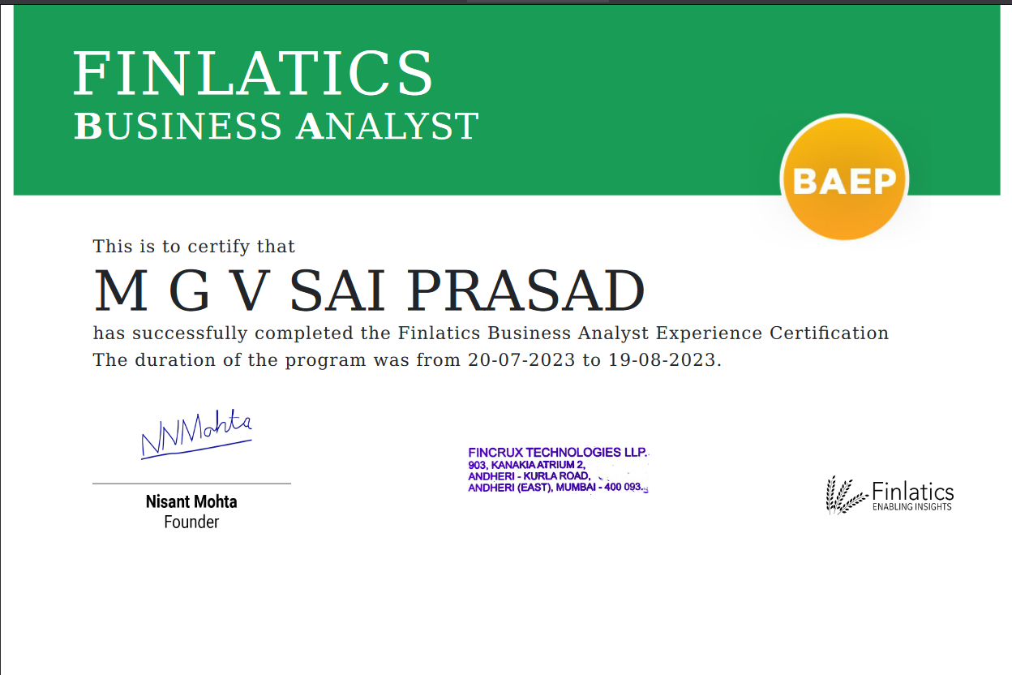

**EXTERNAL GUIDE CERTIFICATE**



**PREFACE**

This project report is a presentation of my effort to study the practices of BUSINESS ANALYTICS in a private company, with reference to Finlatics Mumbai. The report presents the practical and technical approach to the subject of business analysis and data analysis, at Finlatics. It intends to provide brief knowledge of various concepts, principles, approaches, and considerations relevant to this field. Although many gaps may be bridged, the project report has undergone a realistic survey of actual theory and practices in Finlatics.

**ACKNOWLEDGEMENT**

With great pleasure, I express my sincere and heart-full gratitude to the DEPARTMENT OF BACHELOR OF BUSINESS ADMINISTRATION- GITAM DEEMED UNIVERSITY, VISAKHAPATNAM for providing me with an opportunity to take on this project.

This project is a result of the hard work & sincere effort put in by many hands. I sincerely thank **Mr. Nishant Mohta** Founder & CEO of Finlatics for giving me this opportunity to do my project work in the Visakhapatnam steel plant.

I express my sincere thanks to **Saniya Bahuguna**(mam) and whose supervision, valuable guidance & help enabled me to complete this project work.

**M G V SAI PRASAD**

**Dr. Subhodeep Mukherjee**

**Assistant Professor (GSB)**

**CONTENTS**

CHAPTER I: Introduction

CHAPTER II: Company Profile

CHAPTER III: Theoretical Framework

CHAPTER IV: Analysis of the Study

CHAPTER V: Findings, Suggestions, Conclusion

CHAPTER VI:Bibliography

**CHAPTER I**

**INTRODUCTION**

In today's rapidly evolving business landscape, organizations face ever-increasing challenges and opportunities. To thrive in this dynamic environment, data-driven decision-making has become paramount. This project aims to leverage the expertise of a dedicated Business Analyst to address specific challenges and optimize opportunities within our organization.

**The Essence of Business Analysis**

At its core, business analysis is a discipline that helps organizations understand their business processes, identify areas of improvement, and develop strategies for growth and efficiency. It's akin to peering under the hood of a complex machine, dissecting its components, and making it run smoother. Business analysts serve as the "mechanics" of the business world, examining data, processes, and systems to optimize performance.

**Significance of Business Analysis**

In today's fast-paced and data-driven world, business analysis has never been more critical. Organizations are constantly seeking ways to stay competitive, make informed decisions, and adapt to rapidly changing market conditions. Business analysis equips them with the tools and insights needed to navigate these challenges effectively.

**Understanding the Need**

The need for business analysis arises from various factors. These include:

1. **Data Overload**: In the digital age, organizations have access to an abundance of data. Business analysis helps them make sense of this data, turning it into actionable insights.
2. **Competitive Pressure**: Businesses must stay ahead of the competition. Analysing market trends and customer behaviours is essential for strategic positioning.
3. **Customer-Centric Approach**: Understanding and meeting customer needs is key. Business analysis allows organizations to tailor their products and services to customer expectations.
4. **Cost Optimization**: Efficiency is paramount. By analysing processes, businesses can identify areas where resources are wasted and reduce costs.
5. **Regulatory Compliance**: Businesses must adhere to a host of regulations. Business analysis ensures that organizations meet compliance requirements.
6. **Innovation**: Innovation is crucial for long-term success. Business analysis helps organizations identify opportunities for innovation.

**The Process of Business Analysis**

Business analysis is not a one-size-fits-all process. It is a flexible and adaptable approach that can be tailored to the specific needs and objectives of an organization. However, the general process typically involves:

1. **Understanding the Problem or Opportunity**: This phase involves defining the scope of the analysis, whether it's addressing a problem or seizing an opportunity.
2. **Data Gathering**: Collecting and analyzing data is a cornerstone of business analysis. This includes financial data, market research, customer feedback, and more.
3. **Identifying Needs and Solutions**: Based on the data, business analysts identify the needs of the organization and propose solutions.
4. **Evaluating Solutions**: Proposed solutions are evaluated for feasibility, cost-effectiveness, and alignment with organizational goals.
5. **Implementing Changes**: Once a solution is selected, it is implemented within the organization. This may involve process changes, technology implementations, or other strategies.
6. **Monitoring and Adaptation**: Business analysts continue to monitor the implemented changes, ensuring they meet their objectives. Adjustments are made as needed.

**Key Techniques in Business Analysis**

Business analysts employ a range of techniques to derive valuable insights. These techniques include:

1. **SWOT Analysis**: Examining an organization's strengths, weaknesses, opportunities, and threats.
2. **Data Mining**: Extracting valuable patterns and trends from large datasets.
3. **Use Case Analysis**: Defining system interactions from a user's perspective.
4. **Process Modelling**: Creating visual representations of business processes for better understanding.
5. **Cost-Benefit Analysis**: Evaluating the potential costs and benefits of proposed solutions.
6. **Stakeholder Analysis**: Identifying individuals or groups impacted by a project and understanding their needs.

**Objectives of the study:**

The primary objective of this study is to comprehensively explore and understand the practical applications of the MECE (Mutually Exclusive, Collectively Exhaustive) tree model, Excel data visualizations, and Power BI in the context of data analysis and decision-making. Through the study of the MECE tree model, we aim to develop the capability to structure complex problems in a clear and systematic manner, identifying viable solutions and actionable insights. Additionally, the study of Excel visualizations equips us with the skills to transform data into meaningful and visually appealing representations, fostering a deeper understanding of trends and patterns within datasets. Furthermore, the exploration of Power BI aims to provide us with the tools and knowledge needed to create interactive and informative data visualizations, enhancing our ability to analyze and present data in a dynamic and engaging manner. The overarching objective is to equip ourselves with the skills and methodologies necessary for effective data-driven decision-making, which is vital in a variety of professional fields and industries.

**RESEARCH METHODOLOGY:**

The methodology is a systematic procedure of collecting information to analyse and verify a phenomenon.

They are as follows:

* **DATA:** Dataset and questionnaire given by the finlatics company
* **DATA:** Secondary data and unstructured data
* **SAMPLE SIZE:** overall 60000 samples in 3 projects
* **TOOLS used:**  MECE tree, Excel, Power Bi

**LIMITATIONS OF STUDY**

* The period of study is 6 weeks is not enough to go into the detailed aspects of the study.
* Lack of knowledge. Some of the lack full-fledged knowledge of the concept.
* Time is a major constraint.

**CHAPTER II**

**COMPANY PROFILE**



Finlatics was started in June 2017 with the aim of making finance more accessible, friendly, and fun. It was conceptualized and launched as a foremost work experience platform that helps students experience domains like financial markets, portfolio management, equity research, investment banking, private equity, venture capital, and data-driven decision-making as a highway in their career.

Due to the career acceleration nature of our platform and the impact it can have on lives, Finlatics was one of the companies selected for incubation at the prestigious Atal Incubation Centre – NMIMS, supported by Atal Innovation Mission, NITI Aayog & Government of India. We’re also a recognized ‘Start – Up’ by Department for Promotion of Industry & Internal Trade, Government of India.

**KEY PERSONS**

|  |  |  |
| --- | --- | --- |
| **Sr. No.** | **Name** | **Designation** |
| **1** | Nisant Mohta | Founder & CEO |
| **2** | Neerav Doshi | Co-Founder & COO |
| **3** | Chinmay Das | Associate Head - Programs & Growth |
| **4** | Arvind mourya | Head of the technology |

**CHAPTER III**

**THEORTICAL FRAMEWORK**

Business Analyst

A business analyst uses her knowledge and experience, in combination with the insights generated by a data analyst to make decisions that affect the business. They work within a business or organization to identify and implement improvements to help a company achieve its goal

The distinction between Data Analyst and Business Analyst

Data analysts and business analysts both help drive data-driven decision-making in their organizations. Data analysts tend to work more closely with the data itself, while business analysts tend to be more involved in addressing business needs and recommending solutions.

Data-Driven Decision Making

Data-driven decision-making means making decisions that are supported by data rather than decisions based on observations, gut, or even instinct. With the advancement of technology, the data available to organizations has become tremendous. This abundance of data provides organizations several opportunities to understand their performance to a greater degree, optimize their performance and leverage it for growth.

In simple terms, the process is – collecting, extracting, formatting, and analyzing insights.

Let’s consider a leading online video streaming (OTT) platform with several web series under its belt – some successful and some not. The platform is trying to decide which theme to make a new series on. A big director approaches the platform with an out-of-the-box idea that he knows in his gut is a blockbuster idea. The platform assumes that the director's past success is sufficient proof to back the project. A huge budget is allocated to produce and market the series.

The series is made and subsequently launched, and to everyone’s surprise, its viewership is much below expected. The response is underwhelming, and the platform is likely to make losses.

How could the platform have avoided losses? Could the platform have used data points available to it to make an informed, data-based decision that has more weight than just a gut feeling?

Of course, yes. And this is exactly what more and more OTT platforms are doing.

There are various factors that the platform could have relied on, which are not limited to; but include analyzing similar series made in the past, the director & actors’ past track record, and currently trending themes in the OTT space among others. The likeliness of the show underperforming would have been predictable before the platform took it on.

Advantages of using Data in the decision-making process

* **Risk Assessment** -As often data-enabled insights help us identify that carpet bombs that can be attached to a project that we’re working on. By this, what I mean is that often when you are working on a project, there are certain risks that you know about and you do whatever is within your means to mitigate them. However, there are certain risks that you do not know about, and often – using data insights in the decision-making process; helps you identify these risks.
* **Trend spotting and predicting outcome** - Data insights can make it easier for you to gauge trends, which can help you predict outcomes. You can think about the failed web series example that we spoke about earlier to understand this more in detail. Taking a more practical view of that example, since the OTT platform commissioned the idea based on the credibility of the director, let’s say that even data suggests the same and back his or her credibility and past track record. When we look at the actors’ track records and trending themes in the OTT space, here is where data could paint a different picture and there could be a chance that the actors, who were part of the series, could be more successful in genres that were different from this particular genre. Or there could also be a chance that even though the content theme that the web series was based on is in trend in the OTT space, a plethora of content with the same theme on rival OTT platforms would have added a lot of competition to it and hence, this could be a red flag that could be suggested by data. Hence, as we can see from this; trend spotting becomes much easier with data and as a result taking decisions through it, by using it as a tool along with your knowledge; experience and understanding can enhance the precision of your decisions.
* **Gauge customer satisfaction** -All organizations strive for customer satisfaction. They may or may not achieve it. But it is definitely what they strive for. When we speak about customer satisfaction, a key challenge is – how do you gauge customer satisfaction? This is where data plays a key role. To quote an example, let’s look at FMCG as a domain. In FMCG, customer loyalty is a key measure of customer satisfaction; and often this is defined by repeat purchases by a customer. If we look at the online sales channel, it is often easy to identify repeat purchases as the company’s website or the e-commerce platform through which it is selling its product; often maintains a record of the details of its customers. But what about offline channels? Often, in India; offline channels like Kirana stores do not keep individual customer records of their purchases and the products they have purchased, and hence, it's more difficult to measure customer satisfaction. As a result, marketers have developed a parameter of ‘same-store sales growth to gauge customer satisfaction in offline retail channels. Through this example, we can see how data measurement helps in gauging customer satisfaction through both online and offline mediums.
* **Enables innovation** - Often as a Business Analyst, you have to make decisions on both the market and the product. When we speak about the product, one of your key inputs would be in new product development. More often than not, the success or failure of a product depends on the market. Here is where data plays a critical role in the decision-making process. Using data and with the help of a data analyst, you would be able to study the market – its tastes and preferences and work backwards to develop the product. Often, this reverse engineering process of product development, when done correctly with data is something that helps in ensuring the success of a new product.
* And lastly, data-backed decisions help improve both external and internal processes in an organization. External processes include interactions of an organization with external stakeholders like its customers, vendors, and distribution & promotion partners among others; while internal processes include interactions of an organization with internal stakeholders, predominantly – its employees

A MECE (Mutually Exclusive, Collectively Exhaustive) tree is a structured framework that plays a fundamental role in problem-solving, decision-making, and analytical processes. The MECE tree methodology is a powerful tool that enables individuals or teams to break down complex issues into a well-organized hierarchy of categories and subcategories, ensuring that all relevant elements are considered and that there is no overlap or duplication within the framework. This theoretical framework is particularly valuable in management consulting, strategic planning, and numerous decision-making contexts, as it provides a systematic and transparent approach to dissecting multifaceted challenges.

The first step in constructing a MECE tree is to clearly define the problem or objective you intend to address. This serves as the root of the tree and provides a focal point for the entire analysis. By articulating the problem statement, you establish the context and purpose for the MECE tree, guiding subsequent actions and categorization.

Next, the process involves identifying high-level categories that encapsulate the major dimensions or aspects of the problem. These top-level categories must adhere to the MECE principle, meaning they should be mutually exclusive and collectively exhaustive. In other words, they should cover all relevant dimensions of the problem without any redundancy or overlap. These categories essentially serve as the primary branches of your MECE tree, forming the foundation for the subsequent breakdown.

Once you've established the high-level categories, the next stage is to decompose each of them into subcategories or sub-branches. These subcategories further refine the analysis, adding granularity to the framework. Each subcategory, like its parent category, should also be MECE. This requires careful consideration to ensure that there are no overlaps or gaps in the subcategories' coverage.

This process of decomposition can be iterative, as you may need to continue breaking down subcategories into even more specific elements to thoroughly address the problem. This hierarchical structure creates a tree-like diagram, with the root problem statement at the top, the high-level categories as branches, and the subcategories as further branches. At each level, the framework becomes more detailed and nuanced, providing a systematic and organized way to explore the issue.

A critical aspect of building a MECE tree is the evaluation of completeness and exclusivity at every level. You must continually verify that the categories and subcategories are collectively exhaustive, meaning they encompass all relevant aspects of the problem, and mutually exclusive, meaning there is no duplication or overlap. This careful scrutiny ensures that the MECE tree accurately represents the problem's components and provides a solid foundation for analysis and decision-making.

As the MECE tree is populated with relevant information, data, or insights under each subcategory, it becomes a comprehensive repository of knowledge related to the problem. This information can be gathered through research, analysis, surveys, interviews, or any other relevant data sources. The structured nature of the MECE tree makes it easier to organize and integrate this information effectively.

With the MECE tree fully developed and populated with information, the next step is analysis. You can explore the data within each category and subcategory, identifying patterns, relationships, and insights. This analytical phase allows you to draw conclusions, make informed decisions, and formulate recommendations based on the comprehensive understanding of the problem provided by the MECE tree.

Finally, the MECE tree serves as a powerful communication tool for presenting the results of your analysis and decision-making process to stakeholders. It offers a clear and organized structure that visually represents the various components of the problem and the recommended course of action. This structured approach enhances the clarity and transparency of your findings, making it easier for others to grasp the complexities of the issue and the rationale behind your decisions.

In conclusion, the MECE tree theoretical framework is a systematic and robust methodology for dissecting complex issues and making well-informed decisions. By ensuring that categories and subcategories are mutually exclusive and collectively exhaustive, it helps to create a structured and comprehensive framework that enhances problem-solving, analytical thinking, and effective decision-making in a wide range of fields and industries.

Excel visualization is a crucial aspect of data analysis that simplifies complex information into easily understandable visuals. To establish a practical theoretical framework for Excel visualization, we need to grasp the essential principles and steps involved in the process, while keeping it simple and accessible.

**1.Data Selection and Organization**: Effective data visualization starts with gathering relevant data and organizing it properly. In Excel, this means importing your data, ensuring it's complete, and structuring it in a way that makes sense. This organization sets the stage for creating meaningful visualizations.

**2. Know Your Audience and Objectives**: Before creating visualizations, it's crucial to know who your audience is and what you want to convey. Your visualizations should be tailored to your audience's needs and preferences. Understand their level of expertise and what they're looking to learn or understand from the data.

**3. Choose the Right Type of Visualization**: Excel offers various chart and graph options, from bar charts and line graphs to pie charts and scatter plots. The choice of visualization type depends on the data you have and the story you want to tell. Bar charts are great for comparisons, while line graphs are ideal for showing trends over time.

**4. Keep it Simple and Clear**: Simplicity is key to effective data visualization. Avoid clutter, overly complex designs, or unnecessary decorations. Your visualization should focus on the core message without distractions. Remove gridlines, background colors, or excessive data markers that might confuse your audience.

**5. Labels and Titles Matter**: Proper labeling and titling are essential. Titles should be clear and to the point, helping your audience understand what the chart is about. Labels on axes, data points, and legends should be easy to read and informative. Excel provides options to customize labels and fonts to enhance clarity.

**6. Mind Your Colors and Formatting**: Colors and formatting can make your visualizations more appealing, but use them thoughtfully. Ensure that your color choices are relevant to your message and take into account accessibility, especially for color-blind individuals. Consistency in color schemes and formatting helps maintain a cohesive look across multiple charts in a report.

**7. Interactivity and Dynamic Elements**: Excel allows for interactive and dynamic elements in your visualizations. Features like data validation, slicers, and interactive chart elements enable users to explore the data and customize their views. This is especially useful when presenting data to diverse audiences with different interests.

**8. Trendlines and Annotations**: Trendlines and annotations provide context and insights. Excel allows you to add trendlines to some chart types, highlighting patterns in the data. Annotations, such as text boxes or callouts, can provide additional explanations, making the visualization more informative.

**9. Test and Refine**: Before finalizing your visualization, it's a good practice to test it with a representative audience. Gather feedback and make refinements if necessary to ensure your visualization effectively conveys the intended information.

In summary, Excel data visualization is a powerful tool for turning data into understandable and actionable insights. A straightforward theoretical framework for effective Excel visualization encompasses principles like organizing your data, understanding your audience and objectives, choosing the right visualization type, keeping it simple and clear, labeling and titling, considering colors and formatting, embracing interactivity, using trendlines and annotations, and continuously testing and refining. By following these steps, your Excel visualizations can communicate complex information in a clear and engaging manner, making data analysis more accessible and impactful across various fields and industries.

Power BI is a robust business intelligence tool developed by Microsoft that enables organizations and individuals to visualize, analyze, and gain valuable insights from their data. To establish a theoretical framework for Power BI, it's essential to understand the foundational principles, key components, and core processes involved in effectively using this tool for data analysis and reporting.

**1. Data Sources and Integration**: Power BI starts with data sources. It allows you to connect to a wide variety of data sources, including databases, spreadsheets, cloud services, and on-premises systems. The first step in your Power BI framework is identifying and accessing the relevant data sources. This involves data extraction, transformation, and integration. Power BI's Power Query Editor is a valuable component for data preparation, enabling you to clean, shape, and combine data from multiple sources.

**2. Data Modelling and Relationships**: Data modelling in Power BI involves designing a coherent data structure. You create data tables, define relationships between them, and establish hierarchies and calculated columns. Proper data modelling is pivotal to ensuring that your visualizations accurately represent the underlying data. Power BI's Data Model and DAX (Data Analysis Expressions) language are the tools to achieve this.

**3. Data Visualization:** Data visualization in Power BI is where you bring your data to life. You create reports and dashboards with interactive visuals like charts, tables, maps, and custom visuals. The choice of visuals should align with the information you want to convey. Power BI offers extensive formatting options, themes, and design tools to make your reports visually appealing and informative.

**4. DAX Calculations:** The Data Analysis Expressions (DAX) language is a crucial part of the Power BI framework. DAX allows you to create calculated columns, measures, and calculated tables. These calculations help you perform complex data analysis and add context to your visuals. DAX functions enable you to aggregate, filter, and manipulate data to derive meaningful insights.

**5. Data Refresh and Scheduling:** Power BI provides options for data refresh and scheduling to keep your reports up to date. This step ensures that your visuals reflect the latest data from your source systems. You can configure automatic refreshes on a schedule or use DirectQuery for real-time data access.

**6. Sharing and Collaboration:** Power BI facilitates sharing and collaboration by allowing you to publish reports to the Power BI service. This enables you to collaborate with colleagues, clients, or stakeholders by sharing reports and dashboards. You can also set up security and sharing settings to control access to your reports.

**7. Continuous Improvement:** The Power BI framework includes a commitment to continuous improvement. Microsoft regularly updates the Power BI platform with new features and enhancements. Staying informed about these updates and incorporating new capabilities into your analysis and reporting is an integral part of the framework.

**8. Training and Skill Development:** To effectively utilize Power BI, ongoing training and skill development are vital. Power BI offers a wealth of online resources, including documentation, tutorials, and a vibrant user community. Integrating training and skill development into your framework ensures that you leverage Power BI to its full potential.

In conclusion, Power BI encompasses the fundamental principles of data integration, modelling, visualization, DAX calculations, data refresh, sharing and collaboration, governance and security, mobile and web access, continuous improvement, and training and skill development. By adhering to these principles, organizations and individuals can harness the full potential of Power BI for data analysis, reporting, and decision-making, ultimately leading to more informed and data-driven actions in various industries and domains.

**CHAPTER IV**

**ANALYSIS**

In the period of internship i have assigned with three projects

1. Understanding and implementing MECE model.
2. Making meaningful insights using MS excel.
3. Data visualization through Power Bi.

**Project 1:**

In project 1 I had been assigned a task to identify the problem from a given data using MECE tree model. The data that is given is about a company with attributes like employees, resources, customers, region, revenue and cost of company data.

The resulted MECE tree model is given below

Asia Pac 7%

India 60%

Australia 5%

Middle East 27%

India 27%

Abroad 73&

Resources

Employees

Europe 20%

US 32%

India

Company

Abroad

Customers

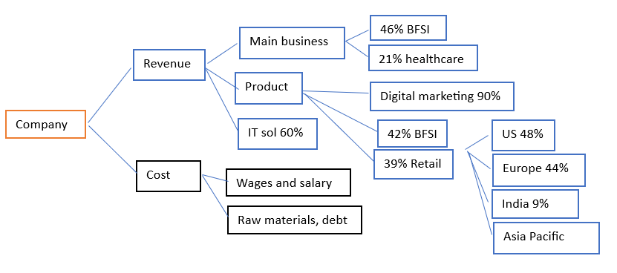

**FINDINGS:**

1. The company is looking forward to investing in India, US and Europe. This would be beneficial and provides growth because of the majority of its customers and resources being spread out across the world. With that in consideration, its revenue is also earned majorly from US and Europe thus the acquisition and investment would provide a larger scope for growth.
2. From the MECE and tree-down structures, we learn that different geographic locations show a different demand for the company. The best option is to increase the products and services in these locations according to their demand.
3. The company investing in each location equally would not invite the best revenue. Analyzing the demand for each location and then increasing the supply of their services and products would be the best way to go forward.

**PROJECT 2:**

In project 2 i was assigned with task to perform analysis on hotel dataset and map data with climatic conditions that those states make a analysis

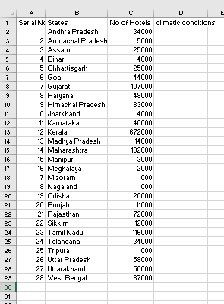

This is the dataset given by the company without climatic conditions of those states. Then the major task inserting the conditions need to be done by the map data that is given by the company

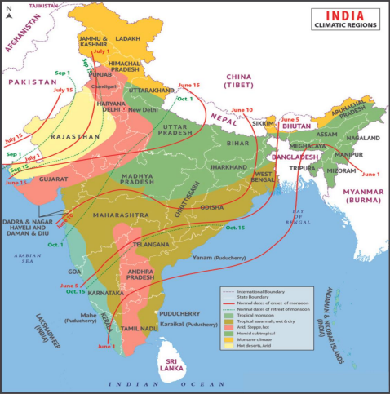

This is the map given by the company with Indian geographical and climatic conditions of the all states.

The conversion of the map data to excel data is done manual by deeply observing the given map.

This process is known as converting unstructured data in to a structured data.

The inserted data with climatic conditions of the states in the excel format is given below.

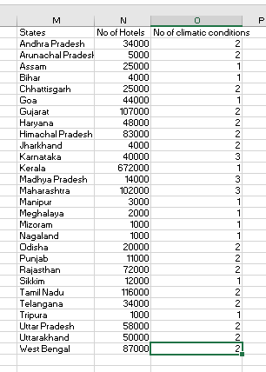

Analysis of the data:

Highest number of hotels states wise:

By the above bar graph we can spot that **Kerala** has the highest number of hotels among the other Indian states.

STATES VS INVESTMENT

By the above pie chart, we can see that **Kerala** is the best state to invest with over 40% followed by Maharashtra and Gujarat with 6%.

**NORTH EASTERN STATES VS HOTEL**

By above bar chart, we can see that **West Bengal** has the highest number of hotels among the other north eastern states followed by assam and Chhattisgarh.

**SOUTHERN STATES VS HOTELS**

By the above bar chart, we can see that Kerala has the highest number hotels among the all-southern states followed by Tamil Nadu.

**NORTHEN STATES VS HOTELS**

By the above bar chart, we can analyze that Himachal Pradesh highest number of hotels with around 83000 followed by Rajasthan with around 72000 hotels.

**PROJECT 3:**

In project 3, I assigned with a task of performing a data analysis using power bi visualization tool with a dataset that is provided by finlatics company.

The dataset consists of various variables and attributes like products, product category, country, city, sales, employee, customers etc.

The glimpse of the dataset is given by

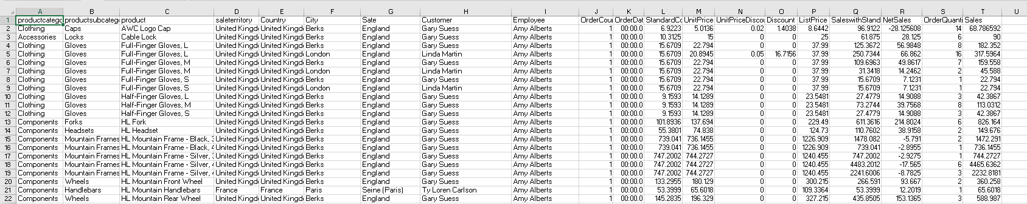

The data visualization tool is placed below

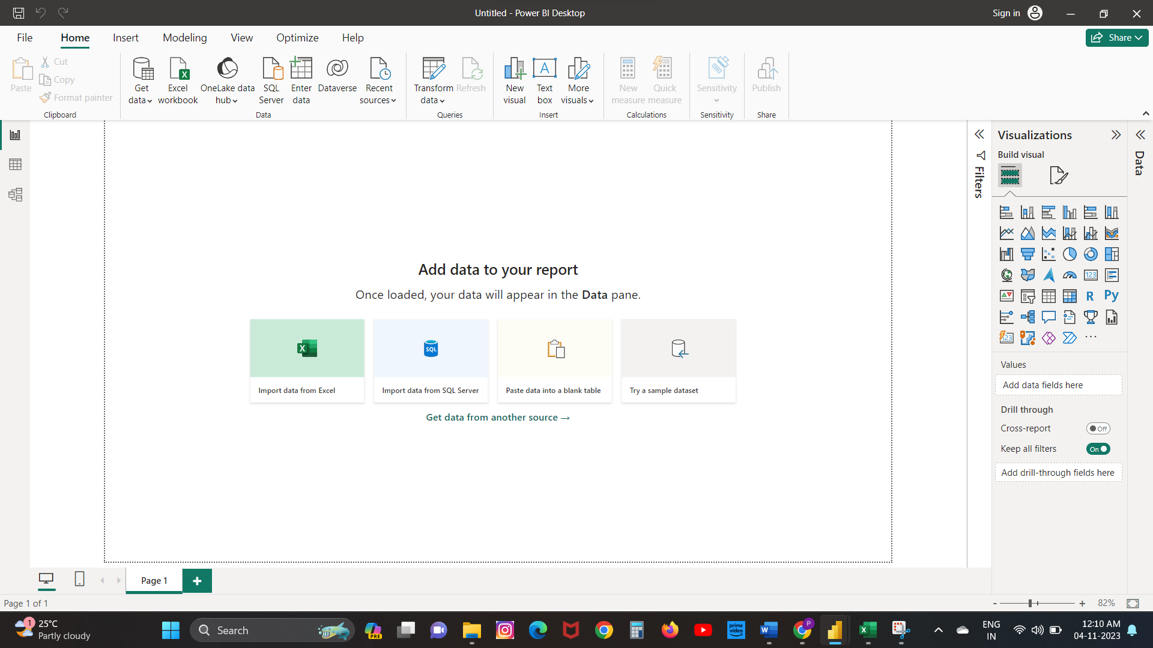

This is the tool named power bi used for high level data visualizations and it user friendly software with various data visualizations to implement and easy access and can be learned easy too.

**SALES VS COUNTRIES**

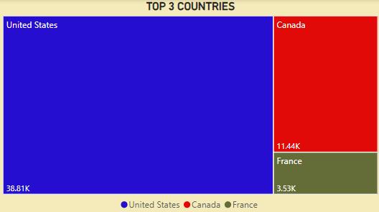

Source: PowerBI

In this visualization, we analyzed the top three countries with highest sales in the given dataset in a tree-map visualization by this we noticed that United States has the highest sales among the other countries with around 38.81k dollars followed by Canada with 11.44k dollars.

**SALES VS PRODUCTS**

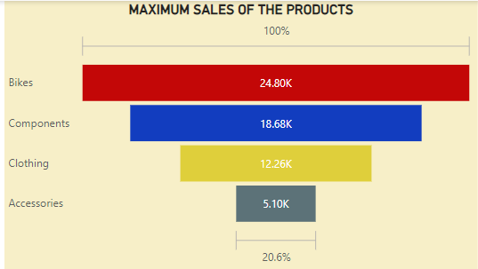

Source: PowerBI

It is a funnel chart visualization used for analysing a maximum sale of the products by product category. I noticed that bikes have a maximum sale with 24.80k dollars followed by components with 18.68k dollars.

**ORDER QUANTITY VS DISCOUNT**

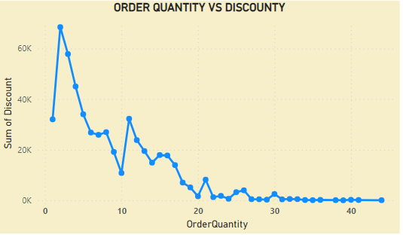

Source: PowerBI

For this visualization we used line chart to describe the discount with respect to order quantity. By this, I noticed that the order quantity with 2 have the highest sum of discount 68k followed by quantity with 2 have the second highest discount of 57k.

**DASHBOARD OF THE POWER BI PROJECT**

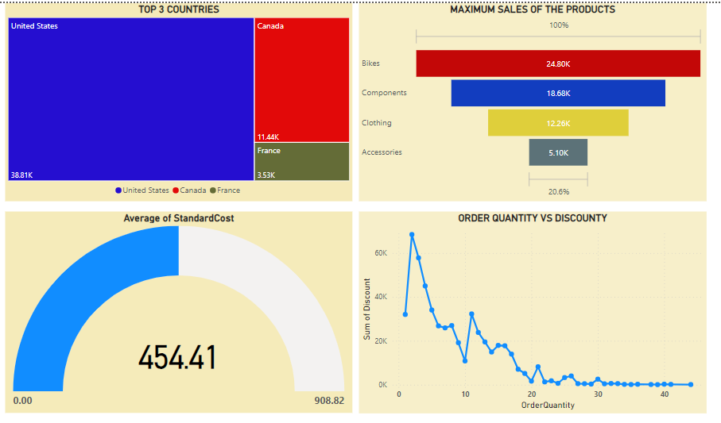

Source: PowerBI

This is the overall dashboard that cumulate with other visualizations and can show desired output changes when we select a specific country or products in the dashboard.

**Dashboard sorting**

**y**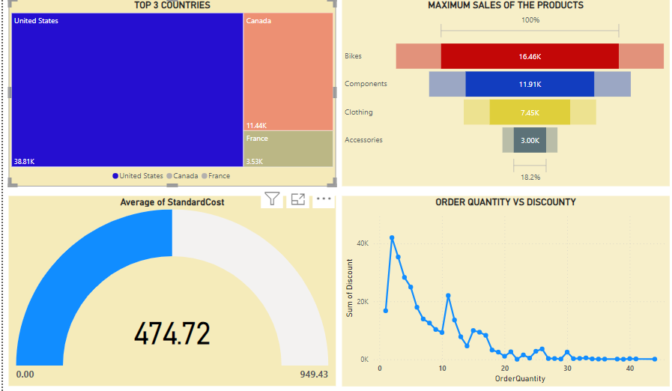

Source: PowerBI

This is visual dashboard resulted by selecting the united states in the tree map resulting the view and analytics of the united states sales and average standard cost and quantity and discount line chart clearly.

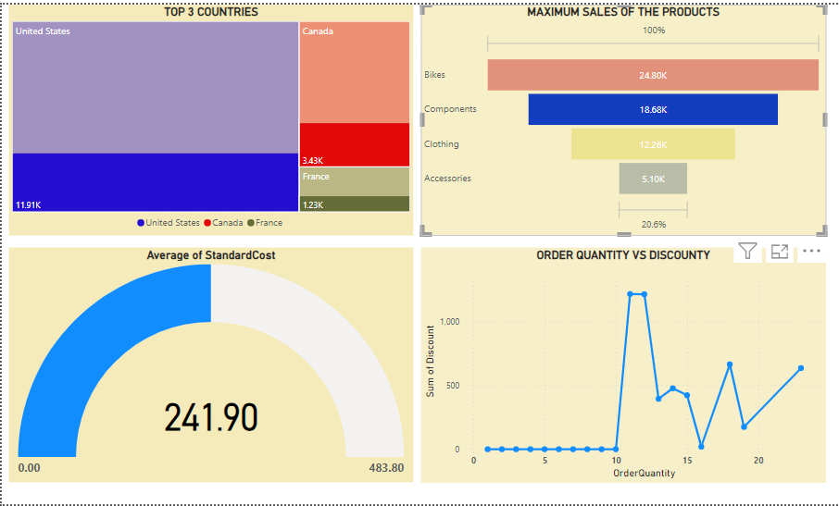

Source: PowerBI

This dashboard is the result of components average standard cost and its distribution of top 3 country sales and quantity vs discount line chart. Similarly, we can see through any type products sales and standard cost and distribution in the countries tree map.

**CHAPTER V**

**FINDINGS**

From the project 1 these are the following

* The company is looking forward to investing in India, US and Europe. This would be beneficial and provides growth because of the majority of its customers and resources being spread out across the world. With that in consideration, its revenue is also earned majorly from US and Europe thus the acquisition and investment would provide a larger scope for growth.
* From the MECE and tree-down structures, we learn that different geographic locations show a different demand for the company. The best option is to increase the products and services in these locations according to their demand.
* The company investing in each location equally would not invite the best revenue. Analyzing the demand for each location and then increasing the supply of their services and products would be the best way to go forward.

From the project 2 these are the following findings

* **Kerala Dominates Hotel Industry**: In the analysis of the hotel dataset, Kerala emerged as the state with the highest number of hotels, indicating a thriving hospitality industry in that region.
* **Kerala as an Investment Hub**: When considering investment in the hotel industry, Kerala appears to be the most promising state, capturing over 40% of the investment share. Maharashtra and Gujarat also show potential with 6% each.
* **West Bengal Leads in North Eastern States**: Among the North Eastern states, West Bengal boasts the highest number of hotels, followed by Assam and Chhattisgarh, indicating that West Bengal has a well-established hotel industry.
* **Himachal Pradesh Leads Northern States**: In the Northern states, Himachal Pradesh stands out with the highest number of hotels, approximately 83,000, surpassing Rajasthan with around 72,000 hotels. This suggests a strong presence of the hotel industry in Himachal Pradesh.

From the project 3

* From the tree map, we analyzed the top three countries with highest sales in the given dataset in a tree-map visualization by this we noticed that United States has the highest sales among the other countries with around 38.81k dollars followed by Canada with 11.44k dollars.
* From the funnel chart, I noticed that bikes have a maximum sale with 24.80k dollars followed by components with 18.68k dollars.
* From the line chart, I noticed that the order quantity with 2 have the highest sum of discount 68k followed by quantity with 2 have the second highest discount of 57k.

**SUGGESTIONS**

1. The mentors of the company need to be more interactive with students.
2. The topics they taught need to be explained in very detailed manner and more interactive sessions needed to be conducted with students.
3. Duration of the internship can be extended cause the mentors doesn’t have enough time to guide the students about analytical skills to the fulliest.
4. The company need to conduct the mock tests and feedback sessions regularly after tasks that are fulfilled.

**CONCLUSION**

From the internship I had done in the Finlatics company, I conclude that I had came to know about the how to handle the techniques like MECE (Mutually Exclusive and Collectively Exhaustive) and tools like Power BI, Microsoft Excel and came to know about its full potential. This internship process has also helped me in upgrading myself to the current world of Business Analytics. I had made myself better in the storytelling and DAX expressions in Power BI. These projects underscored the critical role of data analysis and business intelligence tools in making informed decisions and optimizing organizational processes. They also highlighted the need for structured and high-quality data as the foundation for effective analysis. The experience gained during this internship has equipped me with practical skills and knowledge that will be valuable in the world of business analysis and data-driven decision-making.

**CHAPTER XI**

**BIBOLOGRAPHY**

Company website:

Finlatics - <https://www.finlatics.com/>

MECE tree model reference

<https://www.mbacrystalball.com/blog/strategy/mece-framework/>

Power Bi learning guide

<https://learn.microsoft.com/en-us/power-bi/fundamentals/desktop-getting-started>

<https://en.wikipedia.org/wiki/Main_Page>